

**Term Work**

**On**

**Computer based Numerical and Statistical Techniques**

**(PMA- 502)**

**Submitted to: Submitted by:**

Dr. Prateek Srivastava Prahlad Singh Aswal  
Associate Professor University Roll. No.: 2018550  
GEHU, D. Dun Class Roll No./Section: 39/A

**DEPARTMENT OF COMPUTER SCIENCE AND ENGINEERING**

**GRAPHIC ERA HILL UNIVERSITY, DEHRADUN**

**ACKNOWLEDGMENT**

I would like to particularly thank my Data Science using **JAVA** **PROGRAMMING LANGUAGE** Lab Faculty **DR. Prateek Srivastava** for his patience, support and encouragement throughout the completion of this Term work.

At last, but not the least I greatly indebted to all other persons who directly or indirectly helped me during this course.

Photo [optional]  **Prahlad Singh Aswal**

**Prahladsinghaswal**

**University. Roll No.- 2018550**

**B.TECH CSE-A-IV Sem**

**Session: 2021-22**

**GEHU, Dehradun**

**Table of Contents**

|  |  |  |
| --- | --- | --- |
| **Program No.** | **Program Name** | **Page No.** |
| 1 | Create a class “Student” having following instance variables and methods.  **Instance variables:** ID, Name, Branch and university  **Method:** setDetails() and showDetails().  The setDetails() method sets the values of ID, Name, Branch and University.  And showDetails() method shows the value of each field. |  |
| 2 | Write a Java Program to demonstrate the working of a banking-system  **Instance variables:** name, account_no, amount  **Instance methods:**  deposit(), withdraw(), checkBalance(), insert() and display(). |  |
| 3 | Write a program to sum two numbers. Here inputs are provided through command line argument. |  |
| 4 | Create class Employee with following attributes and methods  ID, name, department and salary.  The setDetails() method sets the values of ID, name, department and salary.  And showDetails() method shows the value of each field |  |
| 5 | Re-write program 1 with better memory management approach. |  |
| 6 | Apply following functions on the String "Java".  (i) Try to concat "Welcome" and write down your observation.  (ii) Find character at index 1  (iii) Find index of first 'a'.  (iv) Find index of second 'a'  (v) Compare "Java" to "JAVA"  (vi) Compare "Java" to "JAVA" ignoring the case  (vii) Find the index of first 'a' from last |  |
| 7 | Apply following functions on StringBuffer object "HELLO"  (i) Append "Java"  (ii) Insert "Java" at index 1  (iii) Replace with "Java" with characters between index 1 to 2  (iv) Delete characters between index 1 and 2  (v) Reverse the string "HELLO" |  |
| 8 | Create a class “Student” having following instance variables and methods.  Instance variables: ID, Name, Branch, city and university  While creating constructors with one, two, three, four and five arguments reuse the constructors by **construction chaining** |  |
| 9 | Create two dimensional integer array and insert, search and traverse this array |  |
| 10 | Create a jagged array having three rows. Where 1st row contains 3 columns, 2nd row contains 4 columns and 3rd row contains 2 columns. Insert and traverse it. |  |
| 11 | Create a class “Shape” having area() method to calculate area. Overload the area() method for shapes like triangle, rectangle and circle. |  |
| 12 | Create a class “Bank” having method getRateOfInterest(). Create child classes as HDFC, SBI and PNB and override getRateOfInterest() and return interest rates as 4.0, 4.5 and 5% correspondingly. |  |

**DEPARTMENT OF CSE**

|  |
| --- |
| Photograph  Passport Size |

**STUDENT LAB REPORT SHEET**

**Name of Student .................................................... Mob. No ......................................**

**Address Permanent .....................................................................................................**

**Father’s Name ........................... Occupation ...................... Mob. No .........................**

**Mother’s Name ........................... Occupation ...................... Mob. No .......................**

**Section ............ Branch ............ Semester ............ Class Roll No ............ Grade A B C**

**Local Address ................................... Email ............................................ Marks 5 3 1**

|  |  |  |  |  |  |  |  |  |
| --- | --- | --- | --- | --- | --- | --- | --- | --- |
| **S.No.** | **Practical** | **D.O.P.** | **Date of Submission** | **Grade (Viva)** | **Grade (Report File)** | **Total Marks (out of 10)** | **Student’s Signature** | **Teacher’s Signature** |
| **1** |  |  |  |  |  |  |  |  |
| **2** |  |  |  |  |  |  |  |  |
| **3** |  |  |  |  |  |  |  |  |
| **4** |  |  |  |  |  |  |  |  |
| **5** |  |  |  |  |  |  |  |  |
| **6** |  |  |  |  |  |  |  |  |
| **7** |  |  |  |  |  |  |  |  |
| **8** |  |  |  |  |  |  |  |  |
| **9** |  |  |  |  |  |  |  |  |
| **10** |  |  |  |  |  |  |  |  |
| **11** |  |  |  |  |  |  |  |  |
| **12** |  |  |  |  |  |  |  |  |

**PRACTICAL 1**

**Question: Create a class “Student” having following instance variables and methods.**

**Instance variables: ID, Name, Branch and university**

**Method: setDetails() and showDetails().**

**The setDetails() method sets the values of ID, Name, Branch and University.**

**And showDetails() method shows the value of each field.**

**Source Code:**

class STUDENT

{

int ID;

String name, University, branch;

void setDetails(int r, String n, String u, String b)

{

ID = r;

name = n;

University = u;

branch = b;

}

void showDetails()

{

System.out.print("\n\n Name : " + name);

System.out.print("\n Roll no : " + ID);

System.out.print("\n University name : " + University);

System.out.print("\n Branch : " + branch);

}

public static void main(String args[])

{

STUDENT obj = new STUDENT();

obj.setDetails(103, "Rohit", "GEHU", "BTECH CSE");

obj.showDetails();

System.out.println("\n");

}

}

**Output**

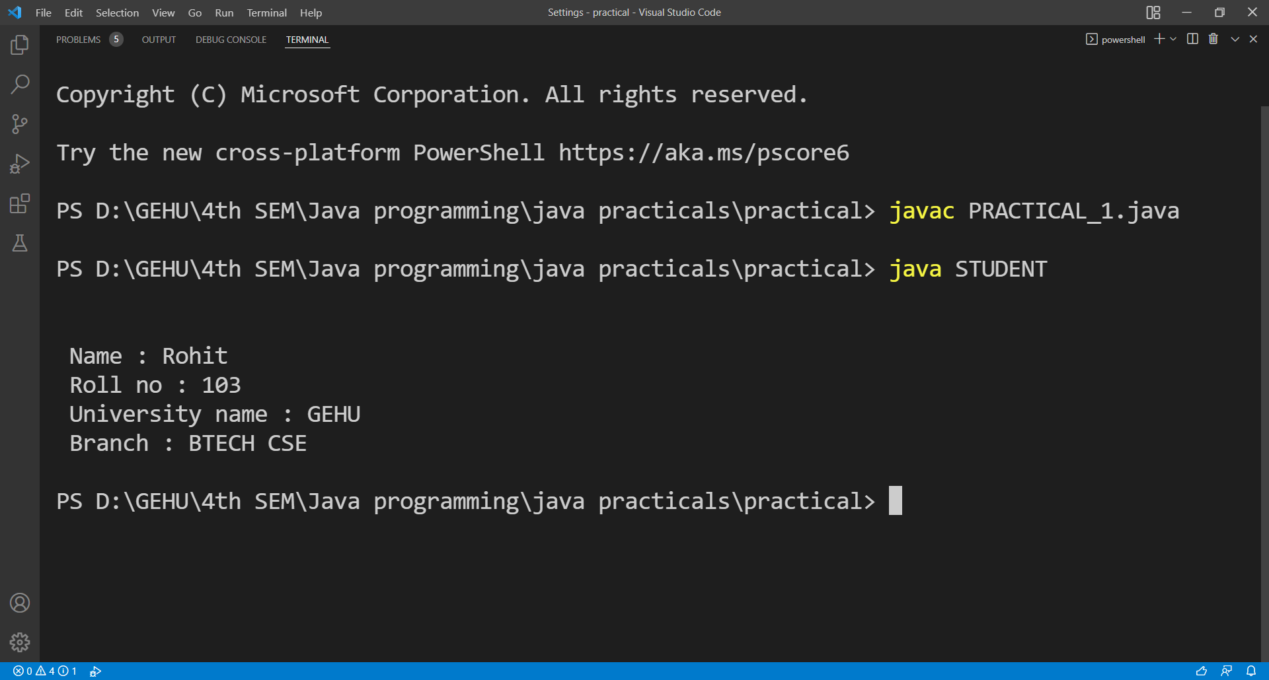

**PRACTICAL 2**

**Question:** . **Write a Java Program to demonstrate the working of a banking-system**

**Instance variables: name, account_no, amount**

**Instance methods: deposit(), withdraw(), checkBalance(), insert() and display().**

**Here we can deposit and withdraw amount from our account using deposit() and withdraw() methods respectively.**

**Source Code:-**

class ACCOUNT

{

int acc_no,amount;

String name;

void insert(int a, int amt, String n)

{

acc_no = a;

amount = amt;

name = n;

}

void deposit(int amt)

{

System.out.println("\nDeposit amount is : " + amt);

amount = amount + amt;

System.out.println("Remaining amount is : " + amount);

}

void withdraw(int w)

{

if(amount < w)

{

System.out.println("\nInsufficient Balance");

}

else

{

System.out.println("\nWithdrawal amount is : " + w);

amount = amount -w;

}

}

void check_balance(int w)

{

System.out.println("\nRemaining amount after withdrawal is : " + amount);

}

void display()

{

System.out.println("\nAccount number: " + acc_no);

System.out.println("Account holder name: " + name);

System.out.println("Amount remaining: " + amount);

}

public static void main(String a[])

{

ACCOUNT obj = new ACCOUNT();

obj.insert(23874, 50000, "Rohan Mishra");

obj.display();

obj.deposit(4000);

obj.withdraw(2000);

obj.check_balance(2000);

obj.display();

System.out.println("\n");

}

}

**Output**

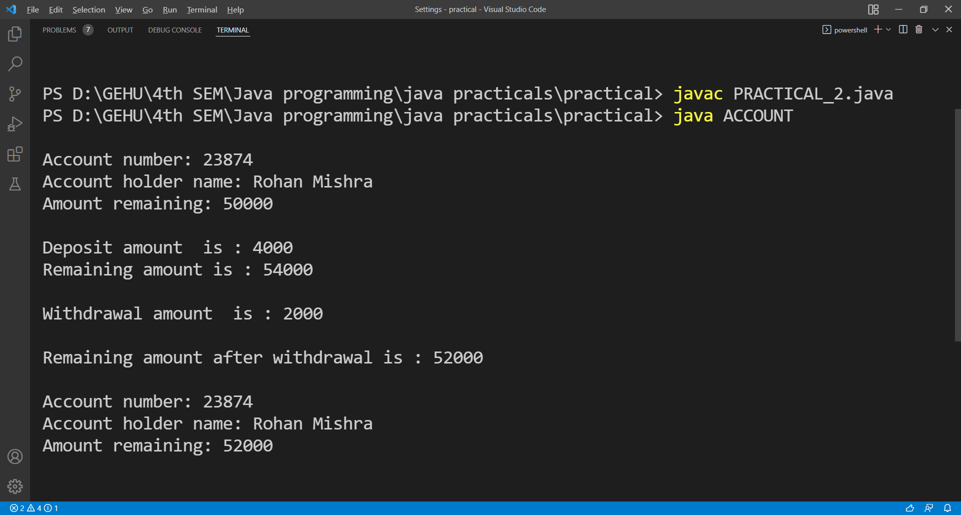

**PRACTICAL 3**

**Question: Write a program to sum two numbers. Here inputs are provided through command line argument.**

**Source Code:**

class ADD

{

public static void main(String args[])

{

int x = Integer.parseInt(args[0]);

int y = Integer.parseInt(args[1]);

System.out.print("\n\nSum of two numbers is : ");

System.out.println(x+y);

System.out.println("\n");

}

}

**OUTPUT**

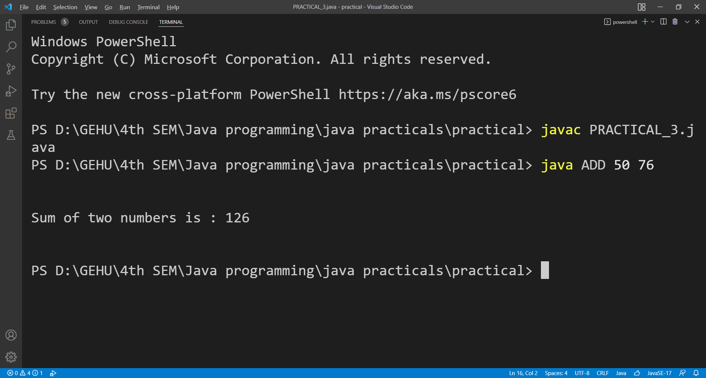

**PRACTICAL 4**

**Question: Create class Employee with following attributes and methods**

**ID, name, department and salary.**

**The setDetails() method sets the values of ID, name, department and salary.**

**And showDetails() method shows the value of each field.**

**Source Code:**

import java.util.Scanner;

class Employee

{

int id;

String name, department;

int salary;

Employee()

{

this.id = 110;

this.name = "RITESH";

this.department = "ACCOUNTS";

this.salary = 50000;

}

void setDetails(int i,String n,String d,int s)

{

this.id = i;

this.name = n;

this.department = d;

this.salary = s;

}

void showDetails(int i)

{

System.out.println("\n Details of " + i + " employee");

System.out.println("\n Id = " + id + "\n Name = " + name);

System.out.println(" Department = " + department + "\n Salary = " + salary);

}

public static void main(String args[])

{

Employee obj1 = new Employee();

Employee obj2 = new Employee();

int i,s;

String n,d;

Scanner input = new Scanner(System.in);

System.out.print("\n\nEnter detail of employee for 2nd object: ");

i = input.nextInt();

n = input.next();

d = input.next();

s = input.nextInt();

obj2.setDetails(i,n,d,s);

obj1.showDetails(1);

obj2.showDetails(2);

System.out.println("\n");

}

}

**OUTPUT**

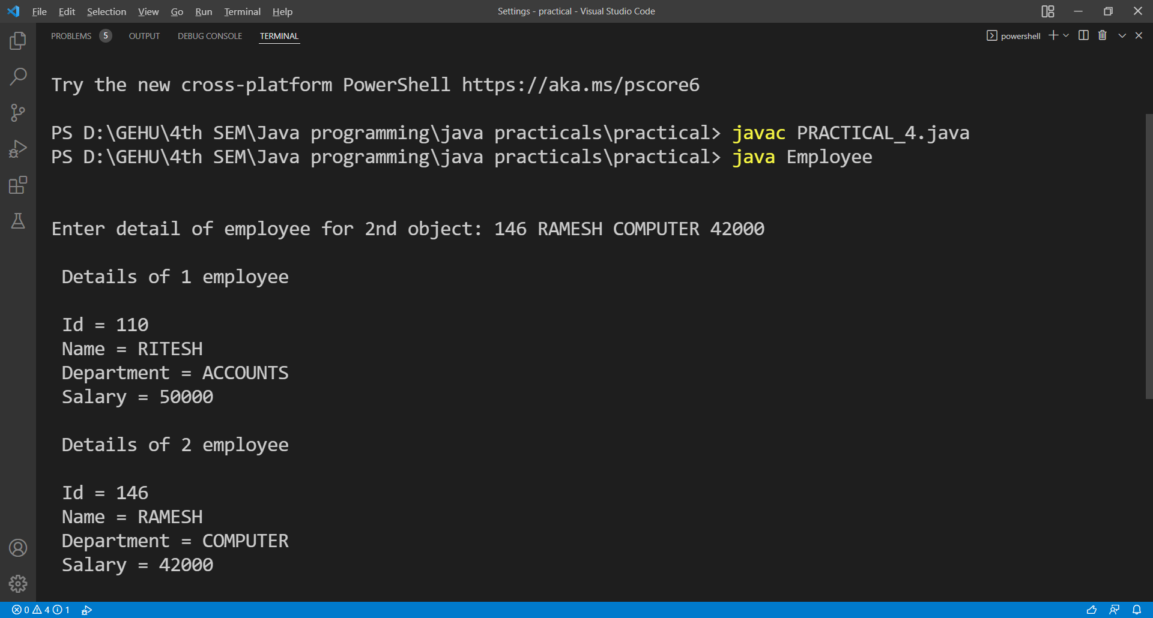

**PRACTICAL 5**

**Question:** Re-write program 1 with better memory management approach.

**Source Code:**

class Student

{

int id;

String name,branch;

static String University = "Graphic Era Hill University";

void setDetails(int i,String n,String b)

{

id = i;

name = n;

branch = b;

}

void showDetails()

{

System.out.println("\n Id = " + id);

System.out.println(" Name = " + name);

System.out.println(" Branch = " + branch);

System.out.println(" University = " + University);

}

public static void main(String args[])

{

Student obj = new Student();

Student obj2 = new Student();

obj2.setDetails(110, "Dhruv","BTECH CSE");

obj.setDetails(125, "Rohan","BTECH CSE");

obj.showDetails();

obj2.showDetails();

System.out.println("\n");

}

}

**OUTPUT**

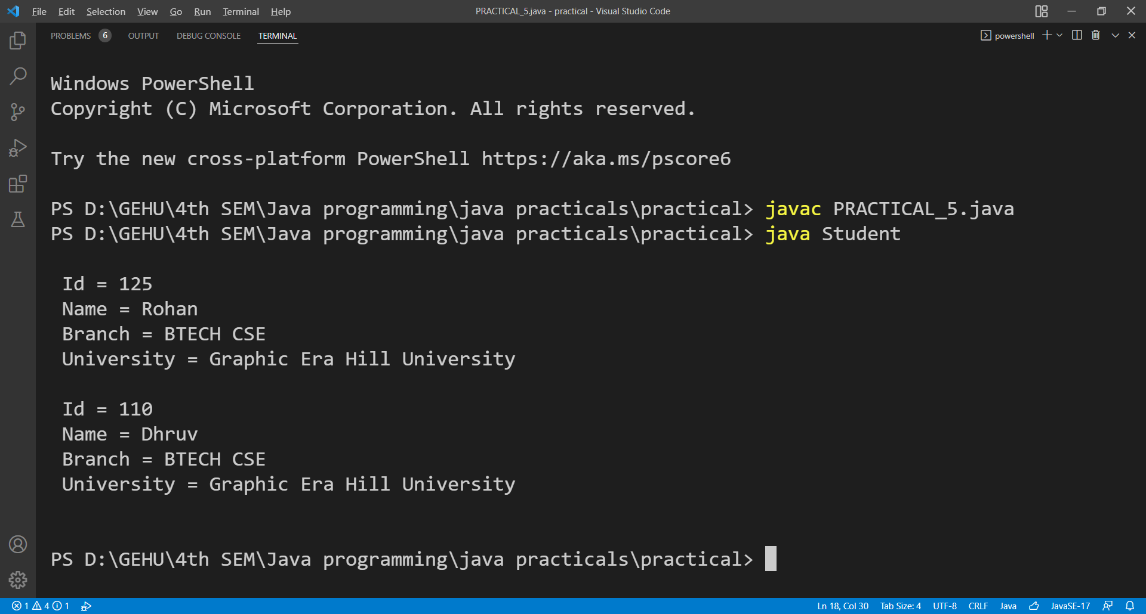

**PRACTICAL 6**

**Question: Apply following functions on the String "Java".**

**(i) Try to concat "Welcome".**

**(ii) Find character at index 1**

**(iii) Find index of first 'a'.**

**(iv) Find index of second 'a'**

**(v) Compare "Java" to "JAVA"**

**(vi) Compare "Java" to "JAVA" ignoring the case**

**(vii) Find the index of first 'a' from last**

**Source Code:**

class String_properties

{

public static void main(String[] args)

{

String str = "Java";

System.out.println("\n");

System.out.println(str.concat(" Welcome"));

System.out.println(str.charAt(1));

System.out.println(str.indexOf('a'));

System.out.println(str.indexOf('a',2));

System.out.println(str.equals("JAVA"));

System.out.println(str.equalsIgnoreCase("JAVA"));

System.out.println(str.lastIndexOf('a'));

System.out.println("\n");

}

}

**OUTPUT**

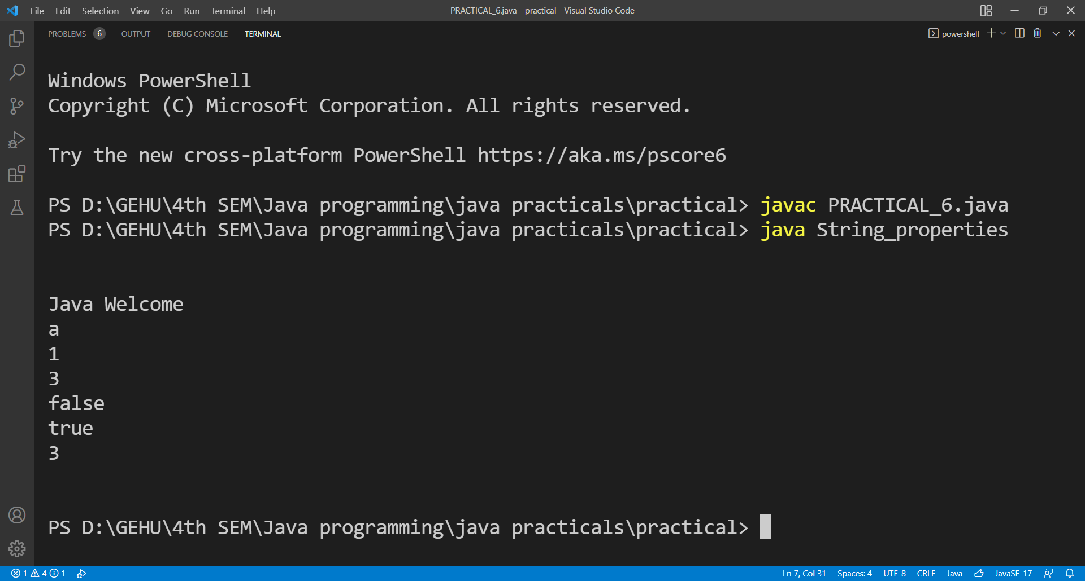

**PRACTICAL 7**

**Question: Apply following functions on StringBuffer object "HELLO"**

**(i) Append "Java"**

**(ii) Insert "Java" at index 1**

**(iii) Replace with "Java" with characters between index 1 to 2**

**(iv) Delete characters between index 1 and 2**

**(v) Reverse the string "HELLO"**

**Source Code:**

class Strings

{

public static void main(String[] args)

{

StringBuffer myStr = new StringBuffer("HELLO");

System.out.println("\n");

System.out.println(myStr.append(" Java"));

System.out.println(myStr.insert(1, "Java"));

System.out.println(myStr.replace(1, 2, "Java"));

System.out.println(myStr.delete(1, 2));

System.out.println(myStr.equals("JAVA"));

myStr = new StringBuffer("HELLO");

System.out.println(myStr.reverse());

System.out.println("\n");

}

}

**OUTPUT**

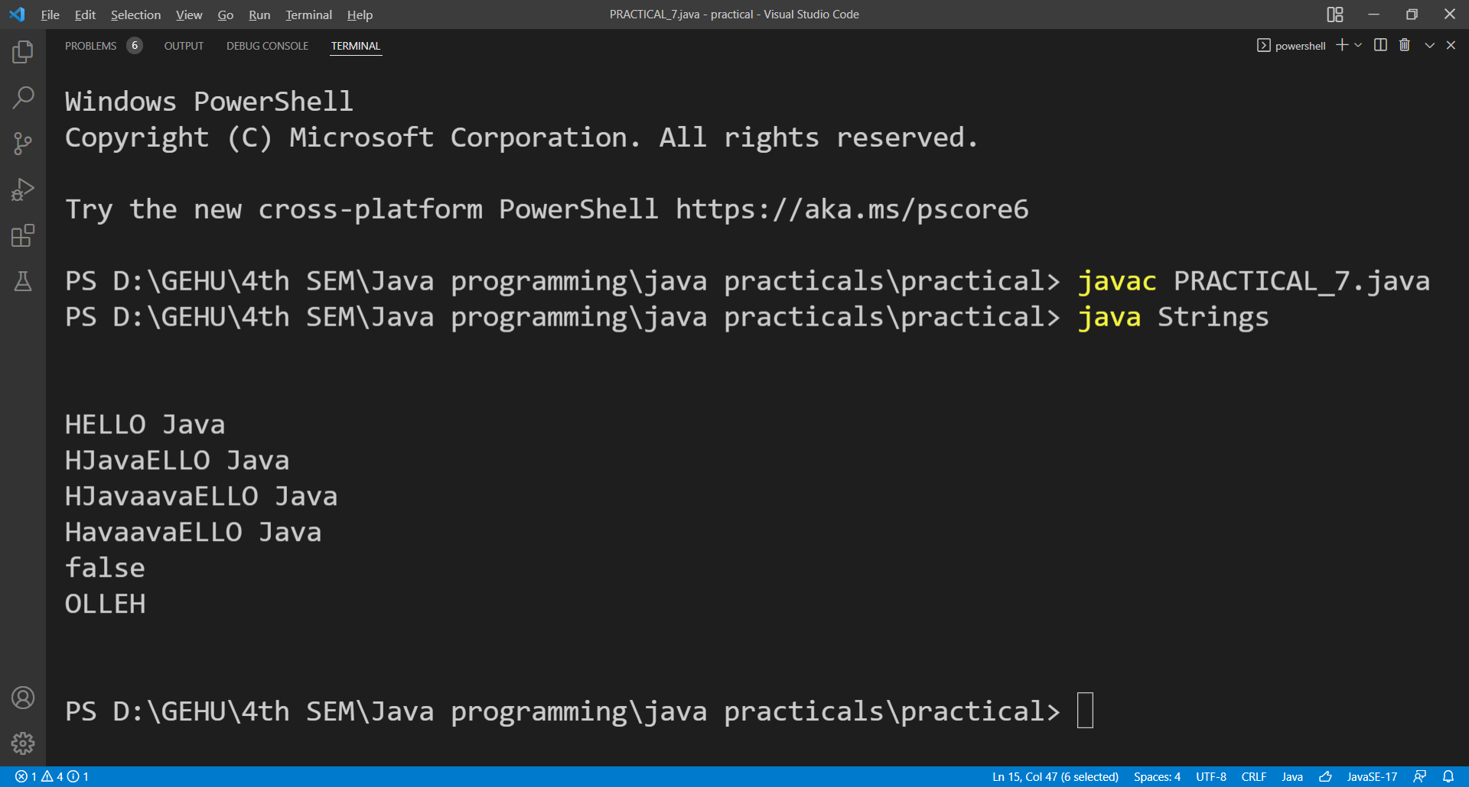

**PRACTICAL 8**

**Question: Create a class “Student” having following instance variables and methods.**

**Instance variables: ID, Name, Branch, city and university**

**While creating constructors with one, two, three, four and five arguments reuse the constructors by construction chaining**

**Source Code:**

class Student

{

int ID;

String Name,Branch,University,city;

Student(int a)

{

this.ID = a;

}

Student(int a, String b)

{

this(a);

this.Name = b;

}

Student(int a, String b, String c)

{

this(a, b);

this.Branch = c;

}

Student(int a, String b, String c, String d)

{

this(a, b, c);

this.University = d;

}

Student(int a, String b, String c, String d, String e)

{

this(a, b, c, d);

this.city = e;

}

void showDetails()

{

System.out.println("\nID = " + ID + "\nName = " + Name + "\nBranch = " + Branch);

System.out.println("\nUniversity = " + University + "\nCity = " + city);

}

public static void main(String args[])

{

Student object = new Student(101, "Rohan", "BTECH CSE", "GEHU", "Dehradun");

object.showDetails();

System.out.println("\n");

}

}

**OUTPUT**

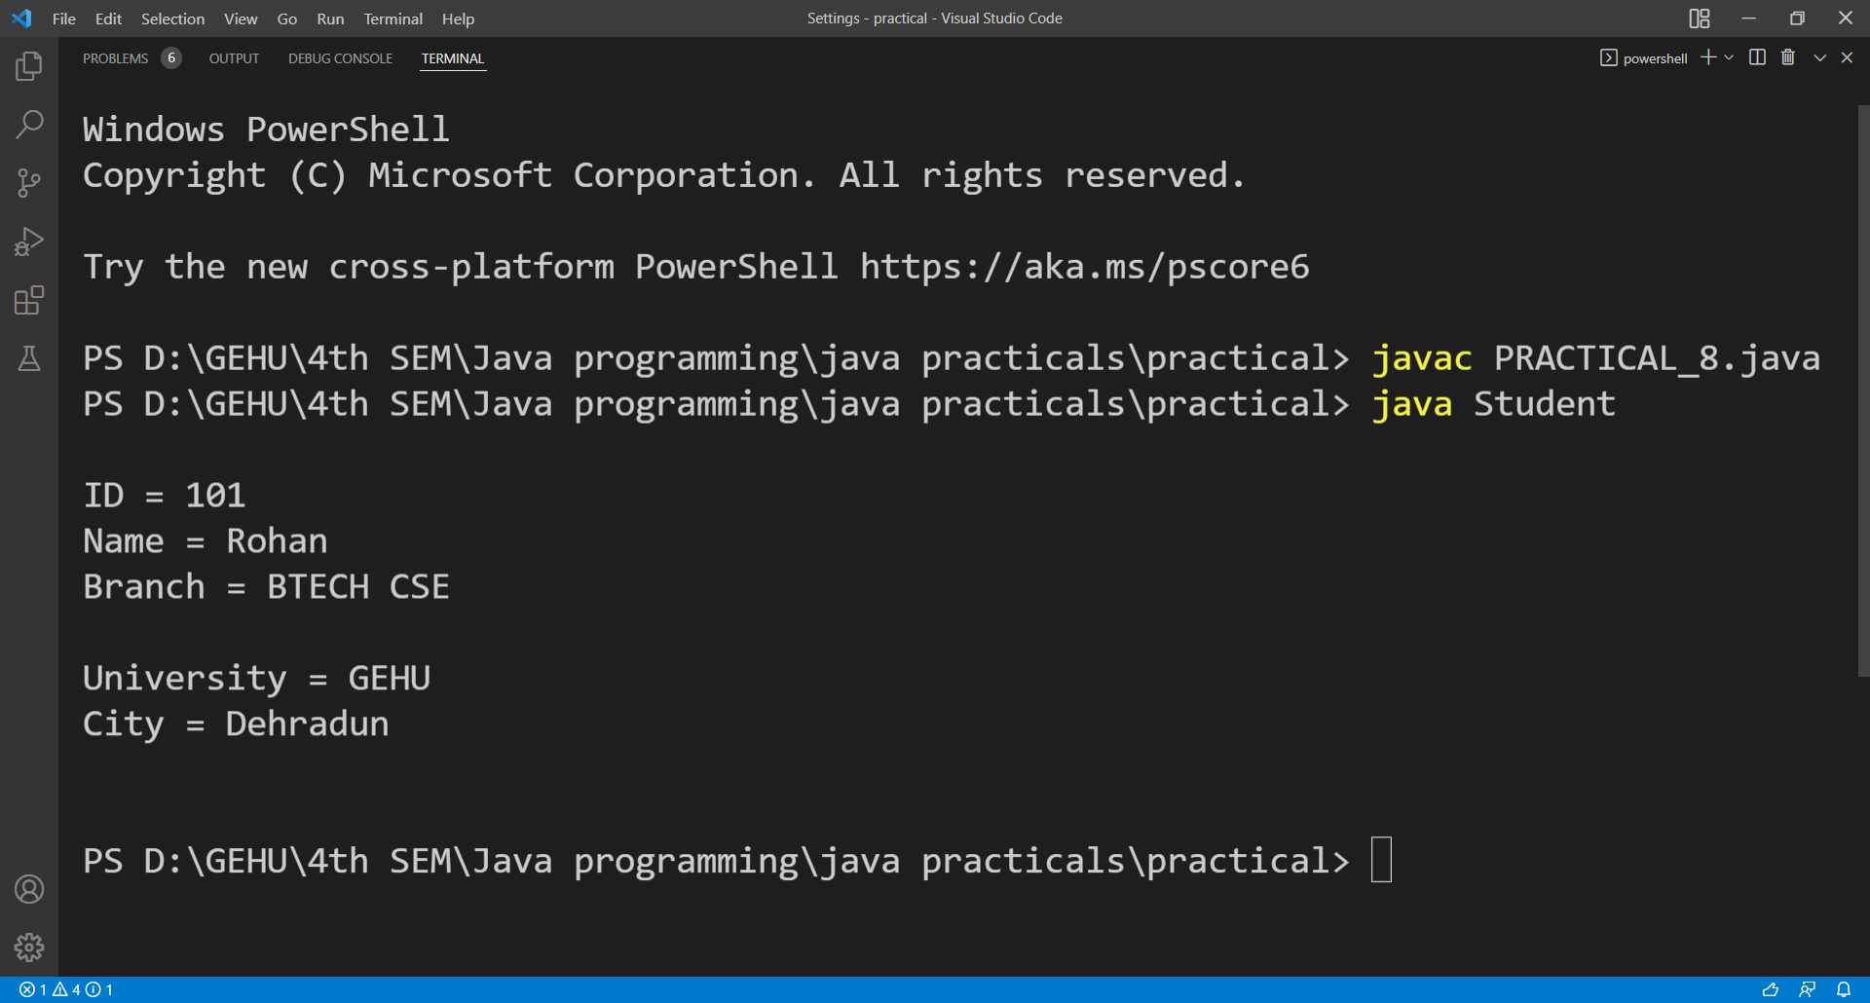

**PRACTICAL 9**

**Question: Create two dimensional integer array and insert, search and traverse this array.**

**Source Code:**

import java.util.Scanner;

class ARRAY

{

public static void main(String[] args)

{

int arr[][] = new int[3][3];

Scanner sc = new Scanner(System.in);

System.out.print("\n\nEnter the elements of array: ");

for (int i = 0; i < 3; i++)

{

for (int j = 0; j < 3; j++)

{

arr[i][j] = sc.nextInt();

}

}

System.out.print("\nEnter the element to search = ");

int x = sc.nextInt();

for (int i = 0; i < 3; i++)

{

for (int j = 0; j < 3; j++)

{

if (arr[i][j] == x)

{ System.out.println("Element Found at: (" + i + "," + j + ")");

break;

}

}

}

System.out.println("\nTraverse of 2-D array");

for (int i = 0; i < 3; i++)

{

for (int j = 0; j < 3; j++)

{

System.out.print(arr[i][j] + " ");

}

System.out.println();

}

System.out.println();

}

}

**OUTPUT**

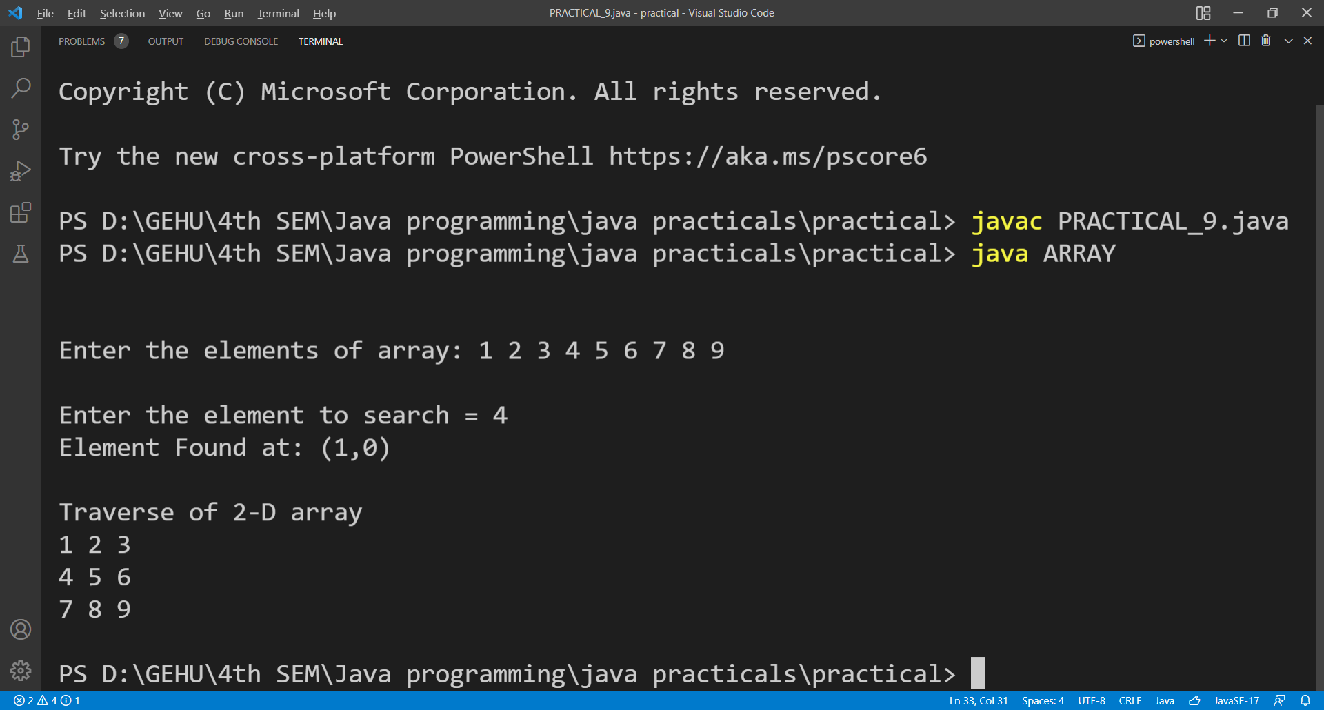**PRACTICAL 10**

**Question: Create a jagged array having three rows. Where 1st row contains 3 columns, 2nd row contains 4 columns and 3rd row contains 2 columns. Insert and traverse it.**

**Source Code:**

import java.util.*;

class jagged {

public static void main(String[] args)

{

int arr[][] = new int[3][];

arr[0] = new int[3];

arr[1] = new int[4];

arr[2] = new int[2];

Scanner sc = new Scanner(System.in);

System.out.print("\n\nInsert element: ");

for (int i = 0; i < 3; i++) {

for (int j = 0; j < arr[i].length; j++)

{

arr[i][j] = sc.nextInt();

}

}

System.out.println("\nTraverse of jagged array");

for (int i = 0; i < 3; i++) {

for (int j = 0; j < arr[i].length; j++) {

System.out.print(arr[i][j] + " ");

}

System.out.println();

}

System.out.println();

}

}

**OUTPUT**

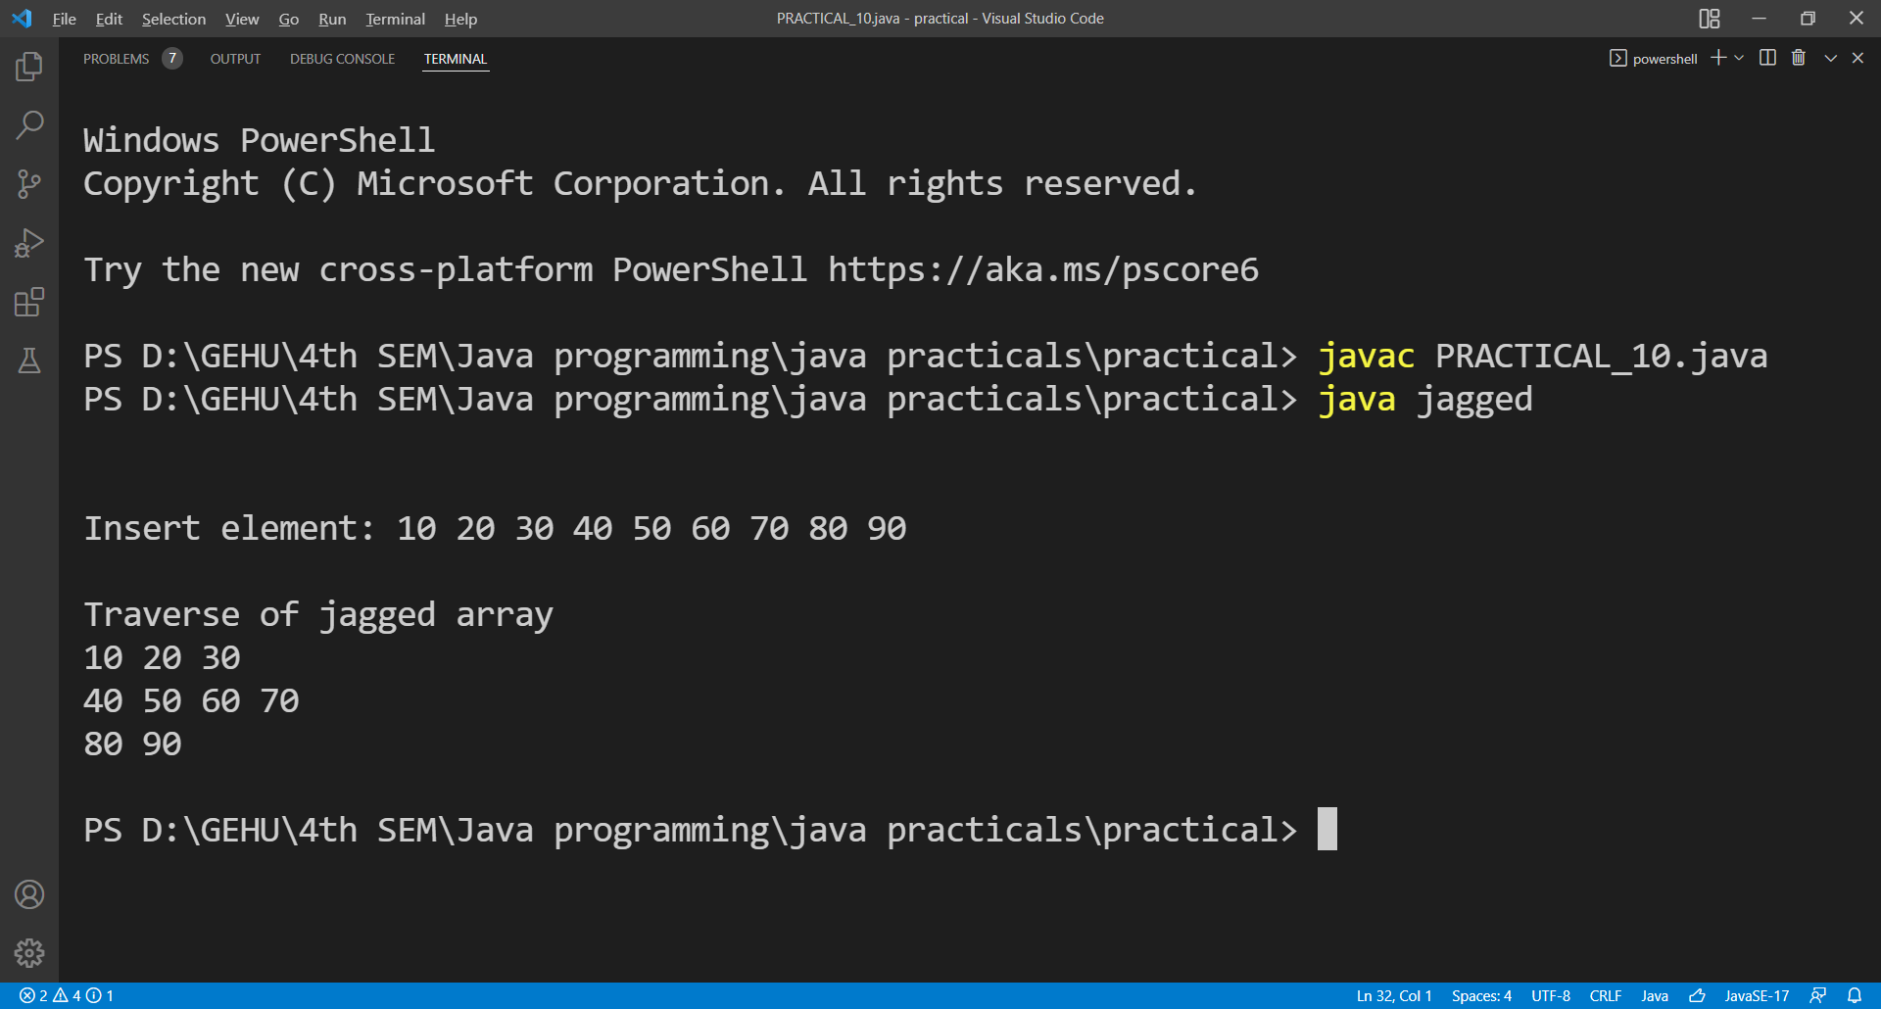

**PRACTICAL 11**

**Question: Create a class “Shape” having area() method to calculate area. Overload the area() method for shapes like triangle, rectangle and circle**

**Source Code:-**

import java.util.Scanner;

class Shape

{

int area(int a,int b)

{

return a*b;

}

int area(int a)

{

return a*a;

}

float area(float r)

{

return (3.14f * r * r);

}

public static void main(String[] args)

{

int l,b,s;

float r;

Scanner ob = new Scanner(System.in);

Shape obj = new Shape();

System.out.print("\n\nEnter the length and width of the rectangle: ");

l = ob.nextInt();

b = ob.nextInt();

System.out.print("\nEnter the side of the square: ");

s = ob.nextInt();

System.out.print("\nEnter the radius of the circle: ");

r = ob.nextFloat();

System.out.println("\nArea of the rectangle is: " + obj.area(l,b));

System.out.println("\nArea of the square is: " + obj.area(s));

System.out.println("\nArea of the circle is: " + obj.area(r));

System.out.println("\n");

}

}

**OUTPUT**

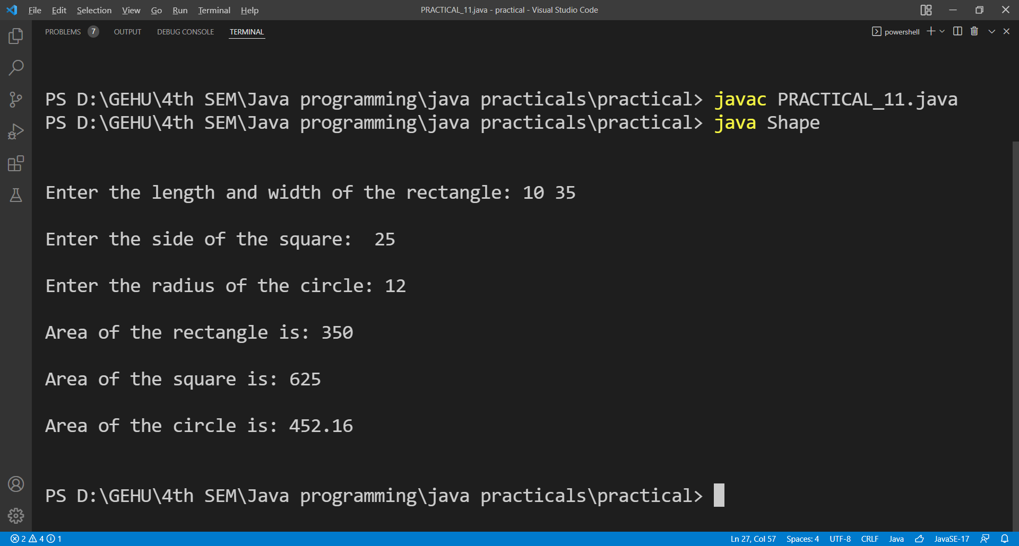

**PRACTICAL 12**

**Question: Create a class “Bank” having method getRateOfInterest(). Create child classes as HDFC, SBI and PNB and override getRateOfInterest() and return interest rates as 4.0, 4.5 and 5% correspondingly.**

**Source Code:**

class Bank

{

float getRateOfInterest()

{

return 2.0f;

}

}

class HDFC extends Bank

{

float getRateOfInterest()

{

return 4.0f;

}

}

class SBI extends Bank

{

float getRateOfInterest()

{

return 4.5f;

}

}

class PNB extends Bank

{

float getRateOfInterest()

{

return 5.0f;

}

}

class BankSystem

{

public static void main(String[] args) {

Bank obj;

obj = new Bank();

System.out.println("\n\n Return of interest in main bank is: " + obj.getRateOfInterest() + " %");

obj = new HDFC();

System.out.println("\n Return of interest in HDFC bank is: " + obj.getRateOfInterest() + " %");

obj = new SBI();

System.out.println("\n Return of interest in SBI is: " + obj.getRateOfInterest() + " %");

obj = new PNB();

System.out.println("\n Return of interest in PNB bank is: " + obj.getRateOfInterest() + " %");

System.out.println("\n");

}

}

**OUTPUT**

